VIBEGETs: 3D-Printable Swipe Surfaces for Small Physical Objects

| 1st Author Name  Affiliation  City, Country  e-mail address | 2nd Author Name  Affiliation  City, Country  e-mail address | 3rd Author Name  Affiliation  City, Country  e-mail address |
| --- | --- | --- |

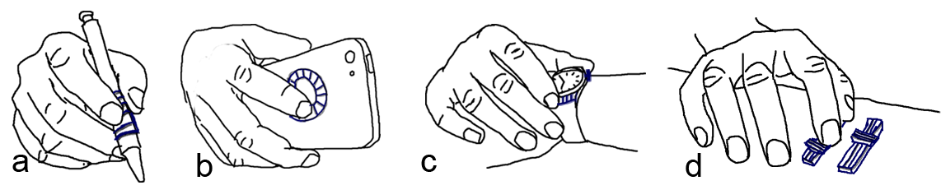Figure . Scenarios of using on hand motion sensors (ring, watch, wrist band) to enhance the use of everyday things. (a) swiping on a textured pad while holding a pen. (b) swiping on a dial pad on the back of a mobile device. (c) pushing a button or swiping on a textured pad on a smart watch. (d) sliding on sliders on a table.

# ABSTRACT

Paste the appropriate copyright/license statement here. ACM now supports three different publication options:

* ACM copyright: ACM holds the copyright on the work. This is the historical approach.
* License: The author(s) retain copyright, but ACM receives an exclusive publication license.
* Open Access: The author(s) wish to pay for the work to be open access. The additional fee must be paid to ACM.

This text field is large enough to hold the appropriate release statement assuming it is single-spaced in Times New Roman 8-point font. Please do not change or modify the size of this text box.

Each submission will be assigned a DOI string to be included here.

Motion sensors embedded in wearable devices, such as sport bracelets, watches and rings, can add new dimensions to the way we use everyday objects. These sensors have the ability to digitalize our finger movements and transmit the information to computing devices for ..... We demonstrate that an accelerometer worn on the wrist or on a finger can accurately detect the distinctive vibrations that occur when a finger swipes over different surface profiles and present VIBGETs – VIBration widGETs – differently surfaced attachable stripes that each generate a different frequency patterns when swiped across. We explore the VIBGETs design space in three user experiments where we investigate elemental design factors such as swipe posture, sensor position, swipe direction, bump height, bump density, softness of stripes. From our results we extract initial guidelines for VIBGET design and then demonstrate several practical usage scenarios where VIBGETs are attached to physical objects to enrich/enable/extend interaction possibilities.

## Author Keywords

Wearable devices; Gestural input; 3D printed widgets; Everyday objects.

## ACM Classification Keywords

H.5.m. Information interfaces and presentation (e.g., HCI): Miscellaneous; See<http://acm.org/about/class/1998> for the full list of ACM classifiers. This section is required.

# INTRODUCTION

Recent research in always-available input has shown the promise of empowering daily objects with touch input capability, where users can interact with their computing devices using touch gestures on any object that is available to them, including walls [ref.] or tables [ref.]. A common approach to implement always-available input is to instrument the environment where the user is in with electronics and sensors [ref.]. This way, touch events can be detected by the sensors embedded in the touched object. Another popular approach requires a specially-designed sensor to be worn on user’s body [ref.]. This allows the user to carry out touch input on the surface of an object, where the movement of the hand or finger is tracked by the body-worn sensor.

Despite the pros and cons of the existing approaches, a common problem of today’s always-available input technology is that the technical burden of using them are too high for ordinary users, who are often lack of necessary skills to use them. For example, users will need to be familiar with capacitive [ref.], acoustic [ref.], or time domain reflectometry [ref.] sensors and need basic electronic skills to ensure the electronics and sensors to be properly installed at home or in the office. Additionally, the structures of the current environment or daily objects need to be well-examined in order for the sensors and wires to be seamlessly embedded. This in most cases can be rather tricky [ref.] and can take substantial efforts from the user.

On the other hand, the state-of-the-art body-worn sensors are usually made ad-hoc for research purpose to demonstrate concept ideas. To date, most of them still remain as research prototypes thus lack of ergonomic design, making them too heavy and bulky to wear in everyday life [ref.]. Finally, none of the existing technique provides an easy-to-use software toolkit to guide the user through the entire design, fabrication, and instrumentation process.

We propose to reduce the burden of enabling touch input on everyday objects through passive clip-on widgets (Figure 1). With passive widgets, ordinary users can easily instrument their environment by attaching the widget to the surface of any object. Users do not need to wear ad-hoc sensors to sense touch events. Instead, existing smart devices worn on user’s wrist or finger (e.g. watch or ring) can be used. We exemplify the capability of the proposed widget through a series of design iterations, and introduce Vidgets, a 3D printed swipe widget consisting a number of carefully-designed bumps on its surface that are used to generate unique patterns of mechanical vibrations on user’s finger during a swipe motion. The vibrational energy patterns can be sensed by the accelerometer in the smartwatch or ring, and can be recognized using a machine learning classifier for contextual actions.

In comparison to the existing methods [ref.], Vidgets can be easily deployed without the need of using special sensors in the environment or on user’s body. Our studies show that using accelerometer alone, Vidgets can reliably identify N different vibrational patterns, making it comparable, in terms of recognition capability, to the existing vision or acoustics based approaches [ref.], which rely on ad-hoc hardware or configuration that are not available in off-the-shelf smartwatches or rings. Equally important, we developed a software toolkit to help the user design Vidgets for objects with surfaces of different shapes. The user can finish the design using our tool, and fabricate the Vidgets using a 3D printer. Our toolkit also provide an easy-to-use interface to allow the user to map different actions to widgets with different vibrational patterns. A final user study shows that given a relatively short period of time, users can use our toolkit to successfully design, fabricate, and deploy Vidgets on a variety of daily objects.

Our contributions of this work are: (1) a demonstration of the accelerometer, that it works and is accurate enough (2) design guidelines, show limit/ranges of fundamental design parameters (material, finger posture, height, density...), and (3) a demonstration of practical use cases for VIBGETs.

# Related Work

In this section, we review the related work in environment and user instrumentation and in the area of context-awareness interactions.

## Instrumenting Physical Objects

Computer vision based techniques have been widely used in supporting touch on existing physical objects. Portico [ref.] and Bonfire [ref.] use RBG cameras installed on a laptop to capture surrounding touch events on a regular tabletop. Light Widgets [ref.] use cameras on the ceiling to detect touch input on walls or tables in a smart home. Recently, more capable depth-sensing cameras have started to replace their 2D counterparts in many interactive applications. For example, Wilson [ref.] showed a depth-sensing camera can be used to detect a wide variety of touch input on a flat surface. LightSpace [ref.] and WorldKit [ref.] use multiple depth-sensing cameras on the ceiling to enable even richer interactions on and between the surfaces of tables and walls.

Other approaches utilize custom-made sensors attached to the touched objects. For example, Pinstripe [ref.] enable touch input on clothing via capacitive sensing threads sewn into the fabric. Similarly PocketTouch [ref.] allows touch to be sensed through fabric but requires the capacitive sensor to be twisted in order to achieve a larger sensing range. Touché [ref.] enables touch input on daily objects, where each object needs to be instrumented with a swept frequency capacitive sensor. Wimmer and Baudisch further extend the concept to allow deformable object to be touch-sensible by using a time domain reflectometry sensor [ref.] that is not easily accessible by novice users.

Acoustic sensors are also widely used in sensing touch. Scratch input [ref.] uses an embedded microphone to detect finger scratches on a table or wall. Toffee [ref.] uses four back-mounted piezo on a mobile device to sense the location of finger taps on the table, on which the device resides. Touch & Activate [ref.] instruments daily objects with two piezo, which sense the change of resonant spectra upon a touch event. Stane [ref.] and Texture pad [ref.] use a piezo microphone attached to a textured surface to sense finger scratches. Acoustic barcode [ref.] takes a similar approach but encodes 1D barcode into the textured surface. Finally, Lamello [ref.] extends Acoustic barcode and apply the technique on passive tangible widgets. Unlike the previous approaches, Vidgets does not use acoustic sensing as microphones are not commonly seen in rings.

Instrumenting the existing electronic devices can also be challenging. Back-of-the-Device input [ref.], for example, utilizes the unused surface on the back of a smartphone for touch input through an “aftermarket” capacitive sensor. Similarly, SideSight [ref.] uses a custom-made proximity sensor array on the sides of a mobile phone to enable touch input on the desk, where the phone resides. FlexAura [ref.] and Multi-touch pen [ref.] enables touch on the barrel of a pen using specially designed touch sensors.

## Instrumenting the User

Custom-made body-worn sensors are also widely used in always-available input [on-body interaction]. Omnitouch [ref.] and Imaginary Phone [ref.] use shoulder-worn depth-sensing cameras to turn a user’s palm into a touch-sensitive surface. Saponas, et al. [ref.] detects different pinch gestures through 10 electromyography sensors worn on a user’s forearm. Skinput [ref.] is a bio-acoustic sensor array also worn on the forearm that can detect taps on the different locations of the arm. iSkin [ref.] is a skin overlay made of thin and flexible biocompatible materials that can sense both capacitive and resistive touch input on the user’s body. Magic Finger [ref.] requires a user to wear a pair of optical sensors (e.g. a low resolution optical flow sensor and a high resolution miniature RGB camera) on the fingertip to track the finger motions on a flat surface of a daily object. LightRing [ref.] achieves the same goal by using a ring-shaped sensing unit, consisting of a gyroscope, an infrared emitter and detector, worn on the base of the finger to avoid occluding the fingertip when performing normal hand functions. Cohn, et al. [ref.] demonstrate that using a neck-worn voltage sensor, the user’s body posture or the location where the user touches on the wall can be detected through the electromagnetic signals radiating from the power lines and walls at home [ref. ref.]. Implanted User Interfaces [ref.] are touch sensors implanted under the user’s skin, a step towards the future where sensors may become disappear from the user’s perspective [ref.].

## Contextual Interactions

Contextual interactions have been widely explored in the ubiquitous computing community. A comprehensive survey can be found in [ref.]. In the context of touch interactions, a variety of interaction techniques have been proposed to allow tabletops to respond differently upon what cause a touch event [ref.] or which user touches it [ref.]. In contrast, Magic Finger [ref.] triggers contextual actions based on the object the user touches. The device uses a miniature RGB camera to distinguish different objects based on the texture of the objects. Other approaches use material’s optical properties to distinguish the objects the sensor touches [SpecTrans, Harrison]. Similar to Magic Finger, these sensors in their current form are too big to be worn in everyday life. Wrist-worn IMU sensors have also been used in context-awareness applications. For example, Object Hallmarks [ref.] uses the IMU sensor in a wrist band to identify the user who is using a home appliance.

To summarize, although most of the existing techniques have shown great sophistication and versatility, they are still not quite accessible by novice users. Vidgets allows the users to easily design and fabricate their own clip-on widgets to instrument small items, on which complex 2D gestures are not preferred. Already popular wrist or finger worn smart devices can be used to detect the touch events and trigger contextual actions.

# PILOT: VIBGET Hardware and software

To explore the feasibility of VIBGETs and detecting vibration patterns with accelerometers, we first built an experimental prototype that includes two IMUs (inertial measurement units) (IMU spec comes here xxxx yyyy zzzz). Figure XYa shows the prototype. One IMU is positioned on the wrist and one on the index finger. With two sensors, we can simultaneously detect vibrations on the finger and on the wrist (we opted not to use the on-board accelerometer in a smartwatch, since we wanted to have the same sensor on the finger for an accurate comparison without device-dependent influences [better formulation needed]). We used a xxyyzzaabb board with a yyzzxxyyy microcontroller and a ZigBee wireless transmitter to continuously send triple-axis acceleration values and absolute orientation values from the two IMUs at 55Hz to a desktop computer, where signal analysis takes place.

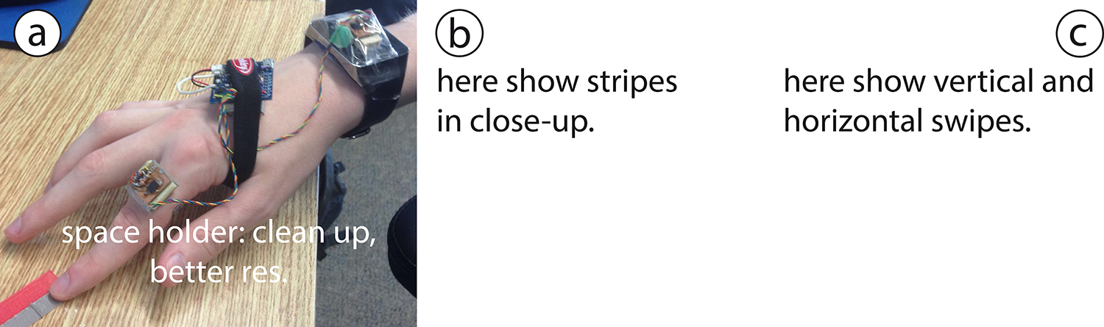

Figure . a) Prototype. b) Swipe stripes. c) Horizontal stripes (or something like this).

To better understand finger and hand motion when swiping over a surface, we asked X persons to alternatively swipe with their index finger along two plastic stripes on a table while wearing the prototype. The stripes measured 1×6 centimeters, one was flat; one had a 1mm high bump in the middle, as shown in Figure XYb. We instructed participants to explore different swipe speeds and finger postures that felt comfortable and natural. Participants performed horizontal swipes (Figure XYc), going from left to right across the stripes, and vertical swipes (Figure XYc), direction, from the top to the bottom. We recorded their swipes in slow motion video mode and collected the accelerometer data from the two IMUs.

The video recordings revealed two main swiping styles. Most swipes were arm-motored with the arm pulling the finger across the surface while the finger posture barely changed. The finger was held in either an upright posture or in a more horizontal posture. With the first style, as depicted in Figure Ya, the fingertip and/or the nail slides across the surface. With the more horizontal posture (Figure Yb), the finger pulp slides across the surface. Next to these two main styles, we also observed joint-motored swipes (Figure Yc) where the surface was traversed by bending the Distal and Proximal interphalangeal joints, which caused a slight raise of the hand and the fingernail to scratch the surface for most parts of the swipe.

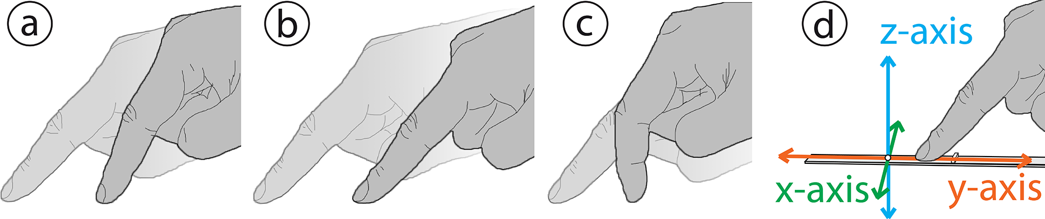

Figure . Swipe styles: arm-motored (a) upright and (b) horizontal swipe styles. (c) Joint-motored swipe style. (d) Vertical swipe in sensor direction... , or something like that...

In the video recordings we could also clearly observe how the finger was quickly raised and dropped (along the z-axis, see Figure 3d) when it moved over a bump. We did not observe any such up-down movements of the hand: presumably, the up-down movements were dampened by the swiping finger and were not propagated to the hand. We also did not see any marked movements along the x-axis (cf. Figure 3d) when the finger crossed a bump. Accordingly, when analyzing the collected sensor data we focused on accelerations along the z-axis and y-axis (the movement direction).

[original text: 1) along the motion direction, the finger’s movement was hindered by the blimp, and (2) orthogonal to the motion direction, the finger was raised by the blimp a little bit and then dropped back to the original level quickly and (3) orthogonal shift on wrist can be barely observed due to hand’s damping effect, but the motion along the moving direction was hindered in the same way (Figure xd). Thus we are interested in studying the motions along and orthogonal to the hand’s moving direction.]

The accelerations in these two directions were calculated by projecting the sensors’ linear acceleration (that is applied due to movement without the gravity force) to the hand moving direction and its orthogonal direction, and adding those sub vectors. For instance, for the sensor attached to the finger parallelly, it mainly rotates along the x-axis. As mentioned, the finger wipes vertically on the stripe, thus the hand moving direction was known. We calculated the vector components for z-acc and y-acc along the moving direction and its orthogonal direction, as shown in Figure X. Notice that x-acc was not used in this case. For horizontal swipes, it works in the same way.

Figure X plots calculated acceleration data along the z-axis and y-axis for two vertical example swipes, one across a bump and one across a stripe with no bump. The left part of the figure shows data from the finger sensor, the right part from the wrist sensor. Along the moving direction (y-axis, orange curve), both sensors respond to the bump (here guide the reader through the figure). Along the z-axis, however, we see marked differences between the two sensor positions with the finger sensor showing greater changes in the acceleration (here guide the reader through the figure).

Figure . Space holder. We need something like this, with axes labels. Calculated accelerations from the finger and wrist sensors.

With these initial insights regarding swipe styles and acceleration data, we followed the methods McGrath et al.’s [17] and Zhang et al.’s [33] to select features to represent the accelerations. Our selected features are xxxxxxxxx, yyyyyyyy, zzzzzzzzz, xyxyxxyxyyxyxyxy, and fkkkkkkkkk. Here please explain/motivate the selected features here.

Both IMUs collects ~55 frames per second, and a swipe gestures usually takes about 0.5 seconds. We extract 32 frames containing the largest acceleration value to calculate features. We make it to 32 frames for convenience of translating the signals into frequency domain. Besides adding the common measurements for brutal force signals as our features, such as standard deviation, skewness and kurtosis of both accelerations (3 * 2), we calculate the largest absolute value difference between two consecutive frames of the signal (1 * 2). In theory, compared to a swipe over a flat surface, a swipe over a bump should cause a sudden shift of the accelerations. Accordingly, the difference between two consecutive frames should increase. Notice, because the sensor output noise often leads to DC shifts – which are unpredictable – we do not use mean values of the acceleration series. Then we did fast frequency transform (FFT) to the signals and recorded the frequency amplitudes as our features. Since we use 32 frames of signals, the FFT function calculates 32 bins over 55Hz, and we were only interested in the first 16 bins based on the Nyquist frequency theory. We converted the result values with a decibel (dB) scale. As a result, we got 16 features on each acceleration. The 1st bin was abandoned as the value was extremely small. In total, there are 38 (8 + 30) features. Notice that these are the features we used for classifying swipes with and without bumps, or with different types of bumps, being aware of swiping direction (vertical or horizontal). To classify swipes with other hand motions like random movements, we added extra features such as displacement, which calculates the sensor’s travelling distance during the 32 frames (not sure yet, need some tests).

As indicated by our initial analysis, the horizontal and vertical swipe directions, swipe styles, and sensor positions are likely to produce different signal patterns. Accordingly, we were interested in knowing how well our classification algorithm performs in the various cases. We explore these factors in our first study, presented in next section.

# STUDY 1: SENSOR POSITION, SWipe direction, and finger posture

The objective with our first study was to explore three fundamental design-related factors that are likely to influence the detection accuracy provided by our and similar systems. We were interested in how the position of the accelerometer, in relation to the swiping finger, influences signal quality and detection accuracy. The further away We study detection accuracy for horizontal and vertical swipes, for swipes over a stripe with a bump and swipes over a flat stripe (i.e., without a bump). two sensor positions (wrist-worn and finger-worn), two swipe directions (horizontal and vertical), and two finger postures when swiping (swiping with the soft finger tip and swiping with the finger nail).

## Data Collection

We collected accelerometer data from swipes from 12 persons (aged xx to yy years, nine males). The collection procedure was identical for all participants. The procedure was as follows. First, the participant was given a background briefing to the study and a demonstration of the swiping task. After that, the participant performed eight series of swipes. Series 1 in vertical swipe direction.

Twelve right-handed persons (9 male) aged xx to yy years participated.

We designed a 2 directions (factor 1: swipe horizontally, vertically) * 2 finger postures (factor 2: swipe with nail, with finger pulp only) * 2 sensor locations (factor 3: sensor on finger, on wrist) study in this section with a 1mm blimp stripe and a smooth stripe as shown before. We used libSVM with Radial Basis Function (RBF) kernel to do the recognition.

12 students (3 female) participants from our university were invited for data collection. They wore the sensors on their right index fingers and wrists such that the two sensors capture signals simultaneously. For each condition, they first swiped on the stripe with blimp (labeled as positive sample) and then swiped on the smooth strip (labeled as negative sample). We wrote a program to prompt them to perform the gestures. The recording lasted for 1.5 seconds such that the participants had enough time to respond. We then subtracted 32 frames manually as explained before. The participants were asked to perform each swipe gesture in comfortable ways for 65 times.

All 12 participants performed 65 swipes in each of the two swipe directions (horizontal, vertical) using the two finger postures (soft finger tip, nail) on two types of stripes, one with a bump and one without a bump. An accelerometer on the index finger and one on the wrist simultaneously sampled acceleration data from each swipe. Accordingly, we collected data from 6240 swipes (12 participants × 2 swipe directions × 2 finger postures × 2 stripe types × 65 repetitions) with each of the two accelerometers for a total of 12480 data records.

With instructions, a few practice swipes, and breaks, a data collection session lasted about 45 minutes.

## Data Analysis and Results

We trained each participant’s data separately since each one had various swiping styles. Some of them swiped hard while some of them swiped fast. The evaluation process is as following: All the feature values were first normalized. Then with the data, the system kept selecting various values for parameter *C* and *gamma* until convergence. For each loop, we used 10-fold cross validation to evaluate the selected *C* and *gamma* values. When converged, the system picked the *C* and *gamma* for the best performance with the data and output the 10-fold evaluation accuracy.

Figure Xb shows the percentage of correctly detected stripes in each of the eight different direction-posture-sensor position combinations. Overall, we observe good performance: in all cases the prediction rate was above 91%, in five combinations the rate was 97.5% or higher.

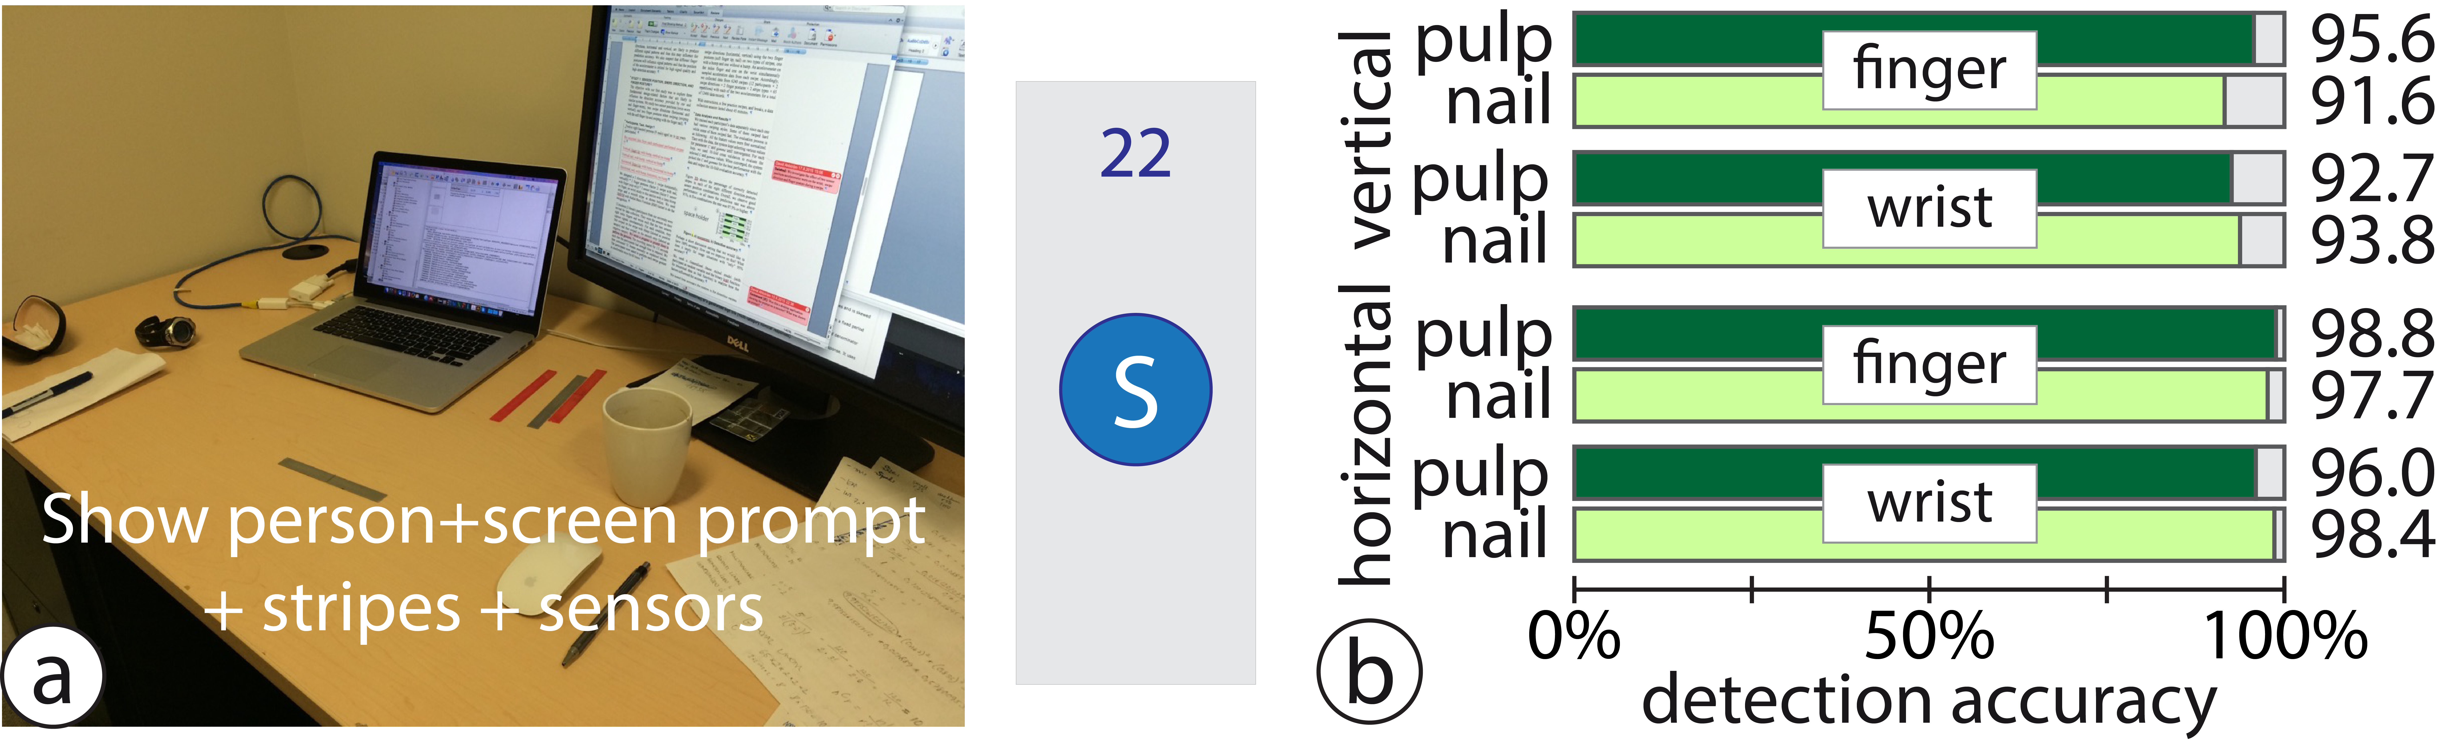

Figure . a) Study setup. b) Detection accuracy.

Perhaps a short discussion saying that we would like to have 100% accuracy. How can we improve on this? What does it imply for usage situations with “only” 95% accuracy?

We used a Generalized linear mixed model (with participant as random variable and the binary logit function for binominal data as link function) to analyze how the factors influenced the accuracy.

We tested how accuracy the system is for detecting swipes with or without blimp under each condition.

The classification accuracy differed between horizontal (97.77%) and vertical swipes (93.42%) (F1,176 = 89.50, p < .001). No significant difference between the flat finger posture (95.81%) and the upright finger posture (95.38). Significant difference (F1,176 = 7.89, p < .01) between wrist sensor (95.26%) and finger sensor (95.93%). Significant difference (F1,176 = 7.73, p < .01) between swipes over bumps (95.40%) and over flat surface (95.78%).

Also interaction effects: direction × stripe (F1,176 = 8.30, p < .01) [In vertical direction bump and no-bump is the same. In horizontal, which had better accuracy for both stripes than in vertical direction, accuracy for no-bump was better than bump. WHY?]

Second interaction: posture × sensor position (F1,176 = 14.68, p < .001). [It seems as if with the upright posture, both sensor positions was equal, but with the flat finger posture the accuracy dropped below that of upright for wrist sensor but the accuracy for finger sensor increased above that of flat finger posture. Grrr... ]

Then we have a three-fold interaction: direction × posture × sensor position (F1,176 = 5.17, p < .05). Pattern the same as by the interaction between posture and sensor position, but relative differences were greater for vertical than horizontal direction. The vertical direction had generally worse accuracy (main effect).

**H**orizontal swipes have higher accuracy than vertical ones since fingers have stronger vibration response when swiping horizontally. Swipes using fingertip only (without nail) have slightly higher accuracy on the finger sensor rather than on the wrist sensor in both directions. This is understandable because the hand wrist tends to dampen more vibration signals than what the finger does. Interestingly, swipes with the nail posture have opposite result for the two sensor positions: we see slightly higher accuracy for the wrist location for both horizontal and vertical swipes. We think that the stripes we used for were made by a 3D printer with relatively low resolution (0.1mm) and not perfectly smooth. When participants swiped using nail, more noise vibrations were introduced since nail is more sensitive to the roughness of the stripes, compared to swipes using finger pulp only. xxx

# Study 2: Bump height, density, stripe length, and softness

Through a multi-part study, we explore the material and geometry characteristics (blimp height, density, uniformity) of blimp patterns that are distinguishable by our algorithm. The outcome of these studies provides some guidelines on the characteristics of blimp parameters to use for designing identifiable widgets. We use two materials in this study, including a hard one and a soft one (details). We first explore different blimp height levels with the two material, and then consider inter-blimp density levels, and uniformity levels with respect to discrimination accuracy. At last, we consider the combination of those parameters.

In study 2, we examine the use of VIBEs for accurate and efficient parameter manipulation.

## Study 1A: Blimp height levels

We evaluate 4 different blimp height levels for the two material.

Study factors: heights (4, 0.6mm, 0.8mm, 1.0mm, 1.2mm) × materials (2) giving a 4×2 factorial design. The task consisted of asking the user to flick over a blimp. The system recorded matching accuracy for each blimp.

Task: flick over blimps under the conditions. Record classification accuracy.

Procedure: We printed 8 stripes (x width by x length, as shown in Figure x) with the 8 conditions. Participants are first required to swipe through the stripes with bare index fingers and asked to point out whether they can tell the difference height levels. The result is used as baseline. Then they wear our prototype device with two motion sensors on index finger and wrist, one each. Similar to the procedure described in the previous section, the participants are given prompt on a monitor and perform swiping gestures on each blimp. Each blimp takes 65 swipes, all without nail, vertically. Swipes with each condition is labeled with a unique number.

Participants: we recruited N=10.

Results: we find that for material A and B, we can identify 3 and 2 levels respectively.

## Study 1B: Inter-blimp density levels

We next evaluate 4 density levels for recognizing inter-blimp density. We pick X height as it is highly recognizable with both materials and then follow the same procedure.

Task: flick over blimps under the conditions. Record classification accuracy.

Study factors: densities (4, x, x, x, x) × materials (2) giving a 4×2 factorial design.

Procedure: We printed 8 stripes (Figure x) following the study factors. Participants are first required to swipe on each of them and asked to tell whether they can feel the difference. Then they wear our prototype device, as in study 1a and swipe on each stripe for 65 times. We index the data for each stripe.

## Study 1C: Uniformity levels

We pick X height and X density and then evaluate 4 levels of uniformities on both material.

Task: flick over blimps under the conditions. Record classification accuracy.

Participants: we recruited N=10. (same group of people?)

Study factors: uniformities (4, x, x, x, x) × materials (2) giving a 4×2 factorial design.

Procedure: We printed 8 stripes (Figure x) following the study factors. Participants are first required to swipe on each of them and asked to tell whether they can feel the difference. Then they wear our prototype device, as in study 1a and swipe on each stripe for 65 times. We index the data for each stripe.

## Study 2: Parameter Manipulation

The prior study allows us to define certain parameters for our blimps for good enough accuracy. We now turn our attention to tasks in which a finger could introduce some effects in an application. We choose parameter manipulation as a canonical task, as it matches the affordance of the gesture and also is universally used for flicking, panning, zooming, menu navigation, selection of values from a multi-item control. Given that such tasks are designed for action in which the user is grasping an object, we investigate the effect of grasp style (tripod, i.e. pen or palm, i.e. smartphone) on performance accuracy. We also investigate the accuracy levels for this task.

Task: the task consisted of moving a virtual cursor onto a given target. We record time to complete, number of overshoot/undershoots. Selection is achieved after the cursor dwells on the target for 200 ms, just enough time to disambiguate from incidental activations during cursor movement.

# VIBE-DGET DESIGN GUIDELINES

Based on our results, we propose the following guidelines to apply in the design of VIBE-DGETS. [Teng: we need to think carefully about how to fill this table and I would like you to start filling it, even before running the studies, so that you know what your studies should provide you as output. You need to think clearly about what will be the most crucial guidelines and include those first, then include the less important ones, then check if the studies will give these or not.]

# VIBE-dgets

Based on the above two studies and our derived guidelines, we design a suite of VIBE-dgets each with their unique affordances.

## Design Example: Textures

M

## Design Example: Form Factors

M

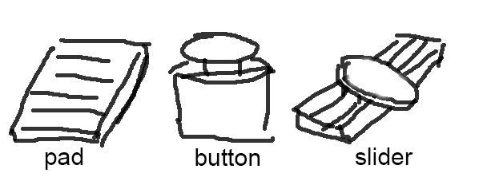

**Figure x. Form factors and their working mechanisms**

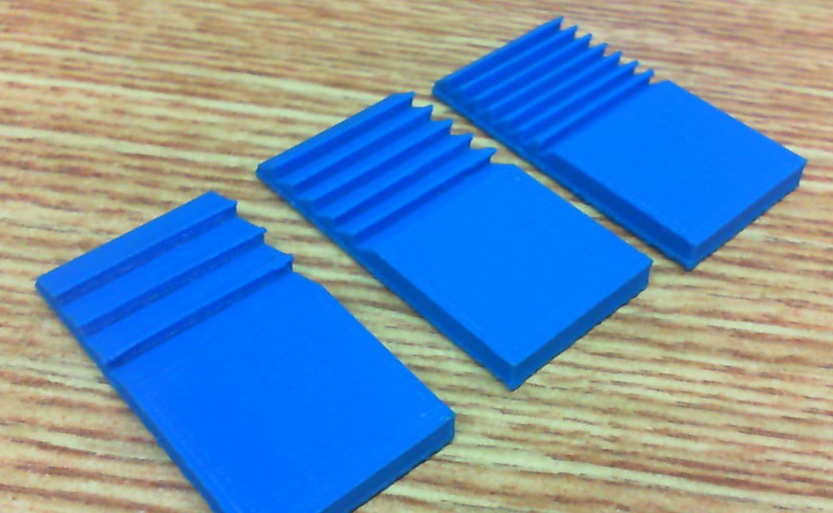

**Figure x. Printed samples**

# DEMO APPLICATIONS and usage scenarios

We demonstrate novel applications and scenarios with VIBE-dgets.

## Pen

In this application, a VIBE-dget with three different blimp patterns allow the manipulation of three parameters, ink thickness, ink color and line format.

## Tools

With

## Driving

With

## Desktop

In this application, the user can flick their finger over the keyboard to issue a given command. A traditional keyboard has 3 different blimp patterns, such as left-to-right, right-to-left, and diagonal movement for effective cursor manipulation, for example, to delete a word, a sentence or an entire paragraph (right-to-left with different lengths), to scroll up/down (up-to-down on keyboard) and to pan a map (diagonal).

Perhaps, small VIBGETs can be attached to the keyboard? The small bumps on the “F” and “J” keys could be used for scrolling by rapidly swiping back and forth.

## Mobile Phone

With

## Tactile Pad for Blind

With

Could a “swipe-pattern” of consecutive swipes work as a password or perhaps entry to a house or car without the need for a key?

# USER FEEDBACK

W

## Let Users Design Their Own Widgets

With

## Subjective Feedbacks

With

# Discussion, Limitations and future work

[Teng: we need to include sub-sections here for what we plan to discuss].

The discussion should include the factors we did not study, but are likely to influence either detection performance or the use of VIBGETs. The first category may include:

* How much can detection accuracy be improved with better sensors?
* Does the length of swipes (swiped distance before the bump and swiped distance after the bump) influence detection accuracy? How short can we go?
* Detection accuracy when swiping on other surfaces (without bumps) than our 3D stripes
* In vertical direction we only studied swipes “toward the body”, not away from the body (when swiping away from the body, the finger is more likely to “get stuck” and pause before going over the bump, i.e., similar to stick-slips on touchscreens)
* The time period between swipes. Can the system detect each swipe in a rapidly performed series of consecutive swipes? Using consecutive swipes could be “combined” into commands...
* Shaky environments, will VIBGETs work?
* We only have “one-dimensional” bumps, what if we swipe across a 2D-array of pimples.
* more ideas?

The second category (user related issues) could include the following:

* How easy is it for a user to remember and learn what functionality is triggered by swipes?
* more ideas?

# CONCLUSION

Conclusions

# REFERENCES

1. Daniel Ashbrook, Patrick Baudisch, and Sean White. 2011. Nenya: subtle and eyes-free mobile input with a magnetically-tracked finger ring. In Proceedings of the SIGCHI Conference on Human Factors in Computing Systems (CHI '11). ACM, New York, NY, USA, 2043-2046.
2. Daniel Avrahami, Jacob O. Wobbrock, and Shahram Izadi. 2011. Portico: tangible interaction on and around a tablet. In Proceedings of the 24th annual ACM symposium on User interface software and technology (UIST '11). ACM, New York, NY, USA, 347-356.
3. Alex Butler, Shahram Izadi, and Steve Hodges. 2008. SideSight: multi-"touch" interaction around small devices. In Proceedings of the 21st annual ACM symposium on User interface software and technology (UIST '08). ACM, New York, NY, USA, 201-204..
4. Liwei Chan, Stefanie Müller, Anne Roudaut, and Patrick Baudisch. 2012. CapStones and ZebraWidgets: sensing stacks of building blocks, dials and sliders on capacitive touch screens. In Proceedings of the SIGCHI Conference on Human Factors in Computing Systems (CHI '12). ACM, New York, NY, USA, 2189-2192.
5. Xiang 'Anthony' Chen, Tovi Grossman, Daniel J. Wigdor, and George Fitzmaurice. 2014. Duet: exploring joint interactions on a smart phone and a smart watch. In Proceedings of the SIGCHI Conference on Human Factors in Computing Systems (CHI '14). ACM, New York, NY, USA, 159-168.
6. Lung-Pan Cheng, Hsiang-Sheng Liang, Che-Yang Wu, and Mike Y. Chen. 2013. iGrasp: grasp-based adaptive keyboard for mobile devices. In Proceedings of the SIGCHI Conference on Human Factors in Computing Systems (CHI '13). ACM, New York, NY, USA, 3037-3046.
7. Chris Harrison, Hrvoje Benko, and Andrew D. Wilson. 2011. OmniTouch: wearable multitouch interaction everywhere. In Proceedings of the 24th annual ACM symposium on User interface software and technology (UIST '11). ACM, New York, NY, USA, 441-450.
8. Chris Harrison and Scott E. Hudson. 2008. Scratch input: creating large, inexpensive, unpowered and mobile finger input surfaces. In Proceedings of the 21st annual ACM symposium on User interface software and technology (UIST '08). ACM, New York, NY, USA, 205-208.
9. Chris Harrison, Robert Xiao, and Scott Hudson. 2012. Acoustic barcodes: passive, durable and inexpensive notched identification tags. In Proceedings of the 25th annual ACM symposium on User interface software and technology (UIST '12). ACM, New York, NY, USA, 563-568.
10. Sungjae Hwang, Myungwook Ahn, and Kwang-yun Wohn. 2013. MagGetz: customizable passive tangible controllers on and around conventional mobile devices. In Proceedings of the 26th annual ACM symposium on User interface software and technology (UIST '13). ACM, New York, NY, USA, 411-416.
11. Shaun K. Kane, Daniel Avrahami, Jacob O. Wobbrock, Beverly Harrison, Adam D. Rea, Matthai Philipose, and Anthony LaMarca. 2009. Bonfire: a nomadic system for hybrid laptop-tabletop interaction. In Proceedings of the 22nd annual ACM symposium on User interface software and technology (UIST '09). ACM, New York, NY, USA, 129-138.
12. Wolf Kienzle and Ken Hinckley. 2014. LightRing: always-available 2D input on any surface. In Proceedings of the 27th annual ACM symposium on User interface software and technology (UIST '14). ACM, New York, NY, USA, 157-160.
13. Ji-Eun Kim, John Sunwoo, Yong-Ki Son, Dong-Woo Lee, and Il-Yeon Cho. 2007. A gestural input through finger writing on a textured pad. In CHI '07 Extended Abstracts on Human Factors in Computing Systems (CHI EA '07). ACM, New York, NY, USA, 2495-2500.
14. Gierad Laput, Eric Brockmeyer, Scott E. Hudson, and Chris Harrison. 2015. Acoustruments: Passive, Acoustically-Driven, Interactive Controls for Handheld Devices. In Proceedings of the 33rd Annual ACM Conference on Human Factors in Computing Systems (CHI '15). ACM, New York, NY, USA, 2161-2170.
15. Rong-Hao Liang, Liwei Chan, Hung-Yu Tseng, Han-Chih Kuo, Da-Yuan Huang, De-Nian Yang, and Bing-Yu Chen. 2014. GaussBricks: magnetic building blocks for constructive tangible interactions on portable displays. In Proceedings of the 32nd annual ACM conference on Human factors in computing systems (CHI '14). ACM, New York, NY, USA, 3153-3162.
16. Rong-Hao Liang, Chao Shen, Yu-Chien Chan, Guan-Ting Chou, Liwei Chan, De-Nian Yang, Mike Y. Chen, and Bing-Yu Chen. 2015. WonderLens: Optical Lenses and Mirrors for Tangible Interactions on Printed Paper. In Proceedings of the 33rd Annual ACM Conference on Human Factors in Computing Systems (CHI '15). ACM, New York, NY, USA, 1281-1284.
17. William McGrath and Yang Li. 2014. Detecting tapping motion on the side of mobile devices by probabilistically combining hand postures. In Proceedings of the 27th annual ACM symposium on User interface software and technology (UIST '14). ACM, New York, NY, USA, 215-219.
18. Marios Papas, Thomas Houit, Derek Nowrouzezahrai, Markus Gross, and Wojciech Jarosz. 2012. The magic lens: refractive steganography. ACM Trans. Graph. 31, 6, Article 186 (November 2012), 10 pages.
19. Young-Woo Park, Joohee Park, and Tek-Jin Nam. 2015. The Trial of Bendi in a Coffeehouse: Use of a Shape-Changing Device for a Tactile-Visual Phone Conversation. In Proceedings of the 33rd Annual ACM Conference on Human Factors in Computing Systems (CHI '15). ACM, New York, NY, USA, 2181-2190.
20. Ring Zero, Logbar Inc. http://logbar.jp/ring/en
21. Munehiko Sato, Ivan Poupyrev, and Chris Harrison. 2012. Touché: enhancing touch interaction on humans, screens, liquids, and everyday objects. In Proceedings of the SIGCHI Conference on Human Factors in Computing Systems (CHI '12). ACM, New York, NY, USA, 483-492.
22. Valkyrie Savage, Andrew Head, Björn Hartmann, Dan B. Goldman, Gautham Mysore, and Wilmot Li. 2015. Lamello: Passive Acoustic Sensing for Tangible Input Components. In Proceedings of the 33rd Annual ACM Conference on Human Factors in Computing Systems (CHI '15). ACM, New York, NY, USA, 1277-1280.
23. Hyunyoung Song, Hrvoje Benko, Francois Guimbretiere, Shahram Izadi, Xiang Cao, and Ken Hinckley. 2011. Grips and gestures on a multi-touch pen. In Proceedings of the SIGCHI Conference on Human Factors in Computing Systems (CHI '11). ACM, New York, NY, USA, 1323-1332.
24. Brandon T. Taylor and V. Michael Bove, Jr.. 2009. Graspables: grasp-recognition as a user interface. In Proceedings of the SIGCHI Conference on Human Factors in Computing Systems (CHI '09). ACM, New York, NY, USA, 917-926.
25. Stuart Taylor, Cem Keskin, Otmar Hilliges, Shahram Izadi, and John Helmes. 2014. Type-hover-swipe in 96 bytes: a motion sensing mechanical keyboard. In Proceedings of the SIGCHI Conference on Human Factors in Computing Systems (CHI '14). ACM, New York, NY, USA, 1695-1704.
26. Cary Williams, Xing Dong Yang, Grant Partridge, Joshua Millar-Usiskin, Arkady Major, and Pourang Irani. 2011. TZee: exploiting the lighting properties of multi-touch tabletops for tangible 3d interactions. In Proceedings of the SIGCHI Conference on Human Factors in Computing Systems (CHI '11). ACM, New York, NY, USA, 1363-1372.
27. Katrin Wolf, Stefan Schneegass, Niels Henze, Dominik Weber, Valentin Schwind, Pascal Knierim, Sven Mayer, Tilman Dingler, Yomna Abdelrahman, Thomas Kubitza, Markus Funk, Anja Mebus, and Albrecht Schmidt. 2015. TUIs in the Large: Using Paper Tangibles with Mobile Devices. In Proceedings of the 33rd Annual ACM Conference Extended Abstracts on Human Factors in Computing Systems (CHI EA '15). ACM, New York, NY, USA, 1579-1584.
28. Xing-Dong Yang, Tovi Grossman, Daniel Wigdor, and George Fitzmaurice. 2012. Magic finger: always-available input through finger instrumentation. In Proceedings of the 25th annual ACM symposium on User interface software and technology (UIST '12). ACM, New York, NY, USA, 147-156.
29. Xing-Dong Yang, Edward Mak, David McCallum, Pourang Irani, Xiang Cao, and Shahram Izadi. 2010. LensMouse: augmenting the mouse with an interactive touch display. In Proceedings of the SIGCHI Conference on Human Factors in Computing Systems (CHI '10). ACM, New York, NY, USA, 2431-2440.
30. Lining Yao, Jifei Ou, Chin-Yi Cheng, Helene Steiner, Wen Wang, Guanyun Wang, and Hiroshi Ishii. 2015. bioLogic: Natto Cells as Nanoactuators for Shape Changing Interfaces. In Proceedings of the 33rd Annual ACM Conference on Human Factors in Computing Systems (CHI '15). ACM, New York, NY, USA, 1-10.
31. Lining Yao, Ryuma Niiyama, Jifei Ou, Sean Follmer, Clark Della Silva, and Hiroshi Ishii. 2013. PneUI: pneumatically actuated soft composite materials for shape changing interfaces. In Proceedings of the 26th annual ACM symposium on User interface software and technology (UIST '13). ACM, New York, NY, USA, 13-22.
32. Neng-Hao Yu, Li-Wei Chan, Seng Yong Lau, Sung-Sheng Tsai, I-Chun Hsiao, Dian-Je Tsai, Fang-I Hsiao, Lung-Pan Cheng, Mike Chen, Polly Huang, and Yi-Ping Hung. 2011. TUIC: enabling tangible interaction on capacitive multi-touch displays. In Proceedings of the SIGCHI Conference on Human Factors in Computing Systems (CHI '11). ACM, New York, NY, USA, 2995-3004.
33. Cheng Zhang, Anhong Guo, Dingtian Zhang, Caleb Southern, Rosa Arriaga, and Gregory Abowd. 2015. BeyondTouch: Extending the Input Language with Built-in Sensors on Commodity Smartphones. In Proceedings of the 20th International Conference on Intelligent User Interfaces (IUI '15). ACM, New York, NY, USA, 67-77.
34. Haimo Zhang and Yang Li. 2014. GestKeyboard: enabling gesture-based interaction on ordinary physical keyboard. In Proceedings of the 32nd annual ACM conference on Human factors in computing systems (CHI '14). ACM, New York, NY, USA, 1675-1684.

According to new format, we need to put DOIs to the references.